**Downloading the Vex IQ software, also known as ‘ROBOTC’**

*To install the correct software you must create a user account first. The following steps will walk through how to create an account and install the RobotC software.

Begin by entering in the following URL: <http://www.robotc.net/download/vexrobotics/>

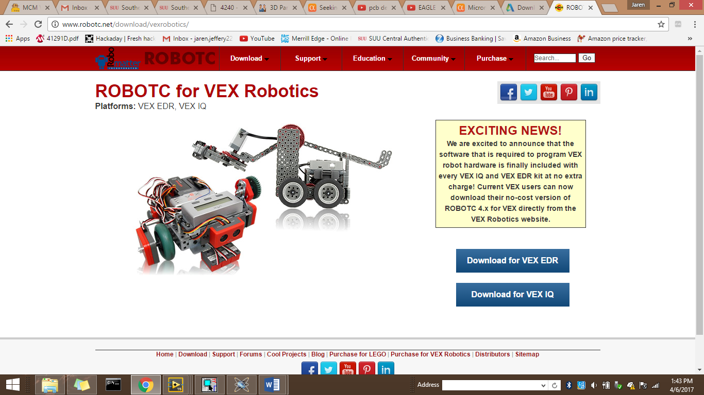-This should take you to the page shown below. Click on the link highlighted in red.

This link will send you to the Vex Robotics home page where you should create your own personal account. Click the icon shown below and then “Log In”

You will then need to create your own account

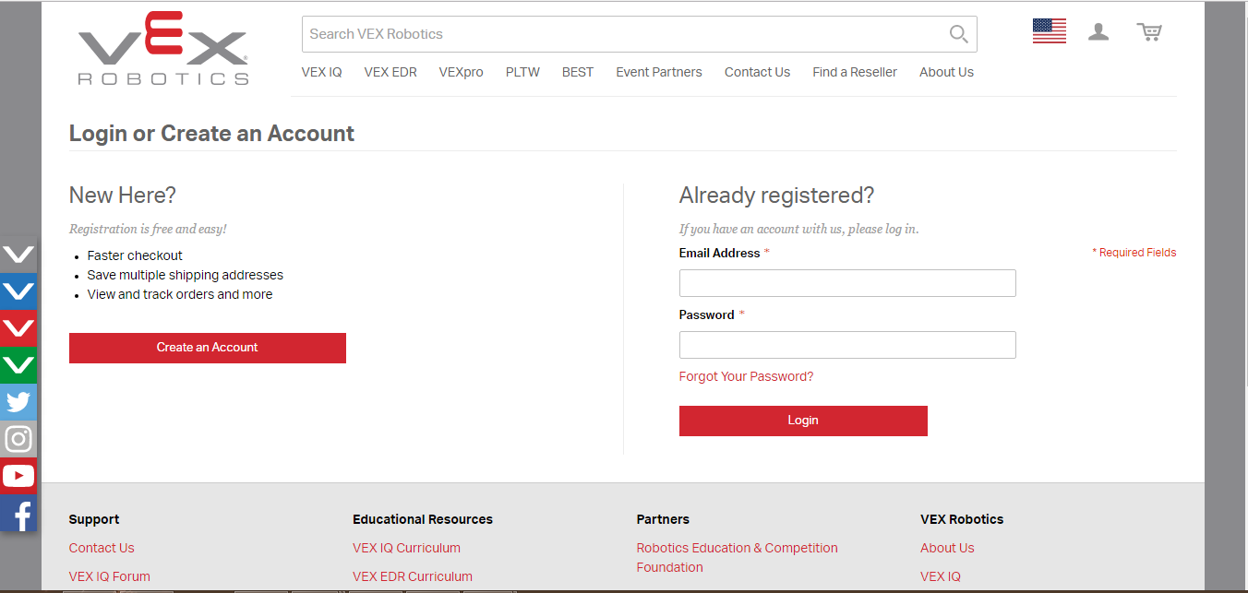After you have completed your account, you should be taken to your ‘Home Dashboard’.

On the right-hand side of your screen, there should be a link for Software Downloads. Click it.

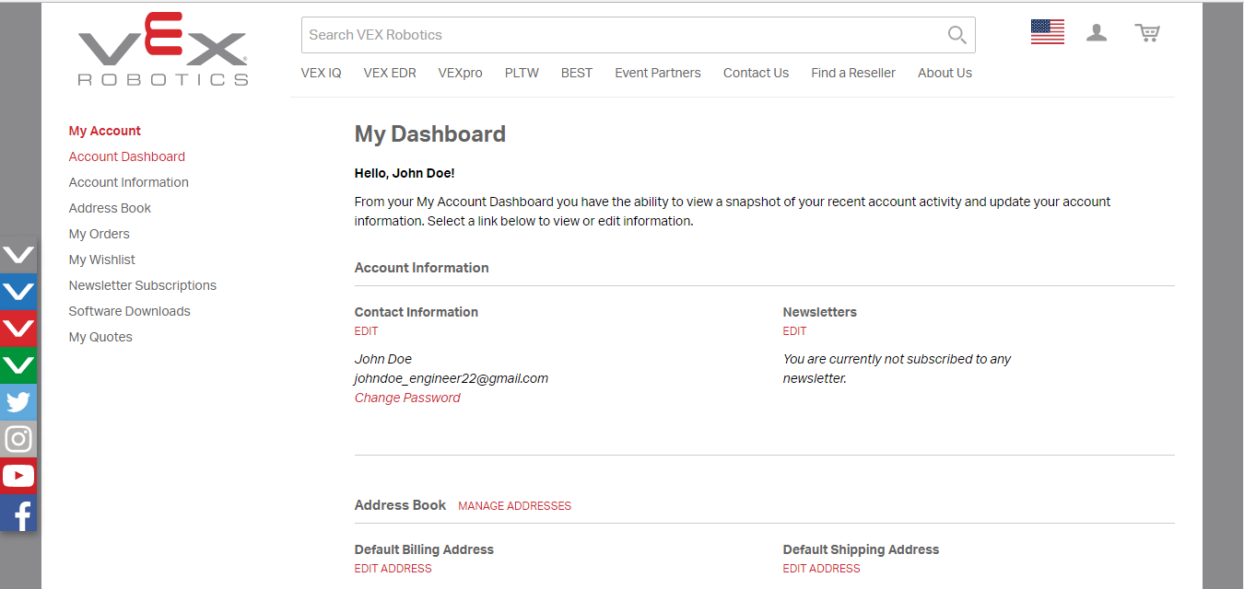

Click on the [ROBOTC for VEX Robotics 4.x (Windows EXE)](http://www.robotc.net/release/vexrobotics/) download to begin download

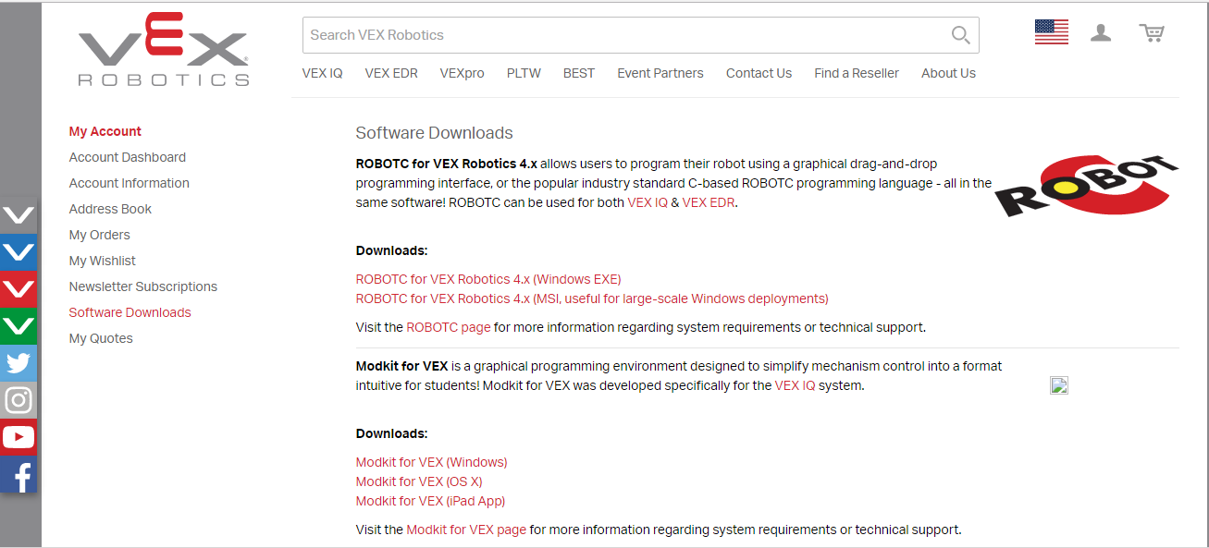

Navigate to the install file and install the new program.

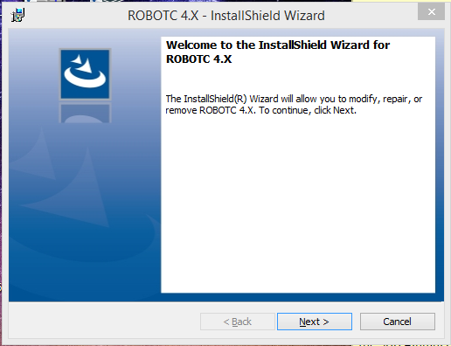

After the install process is completed, locate the shortcut and begin your programming experience with the VexIQ software